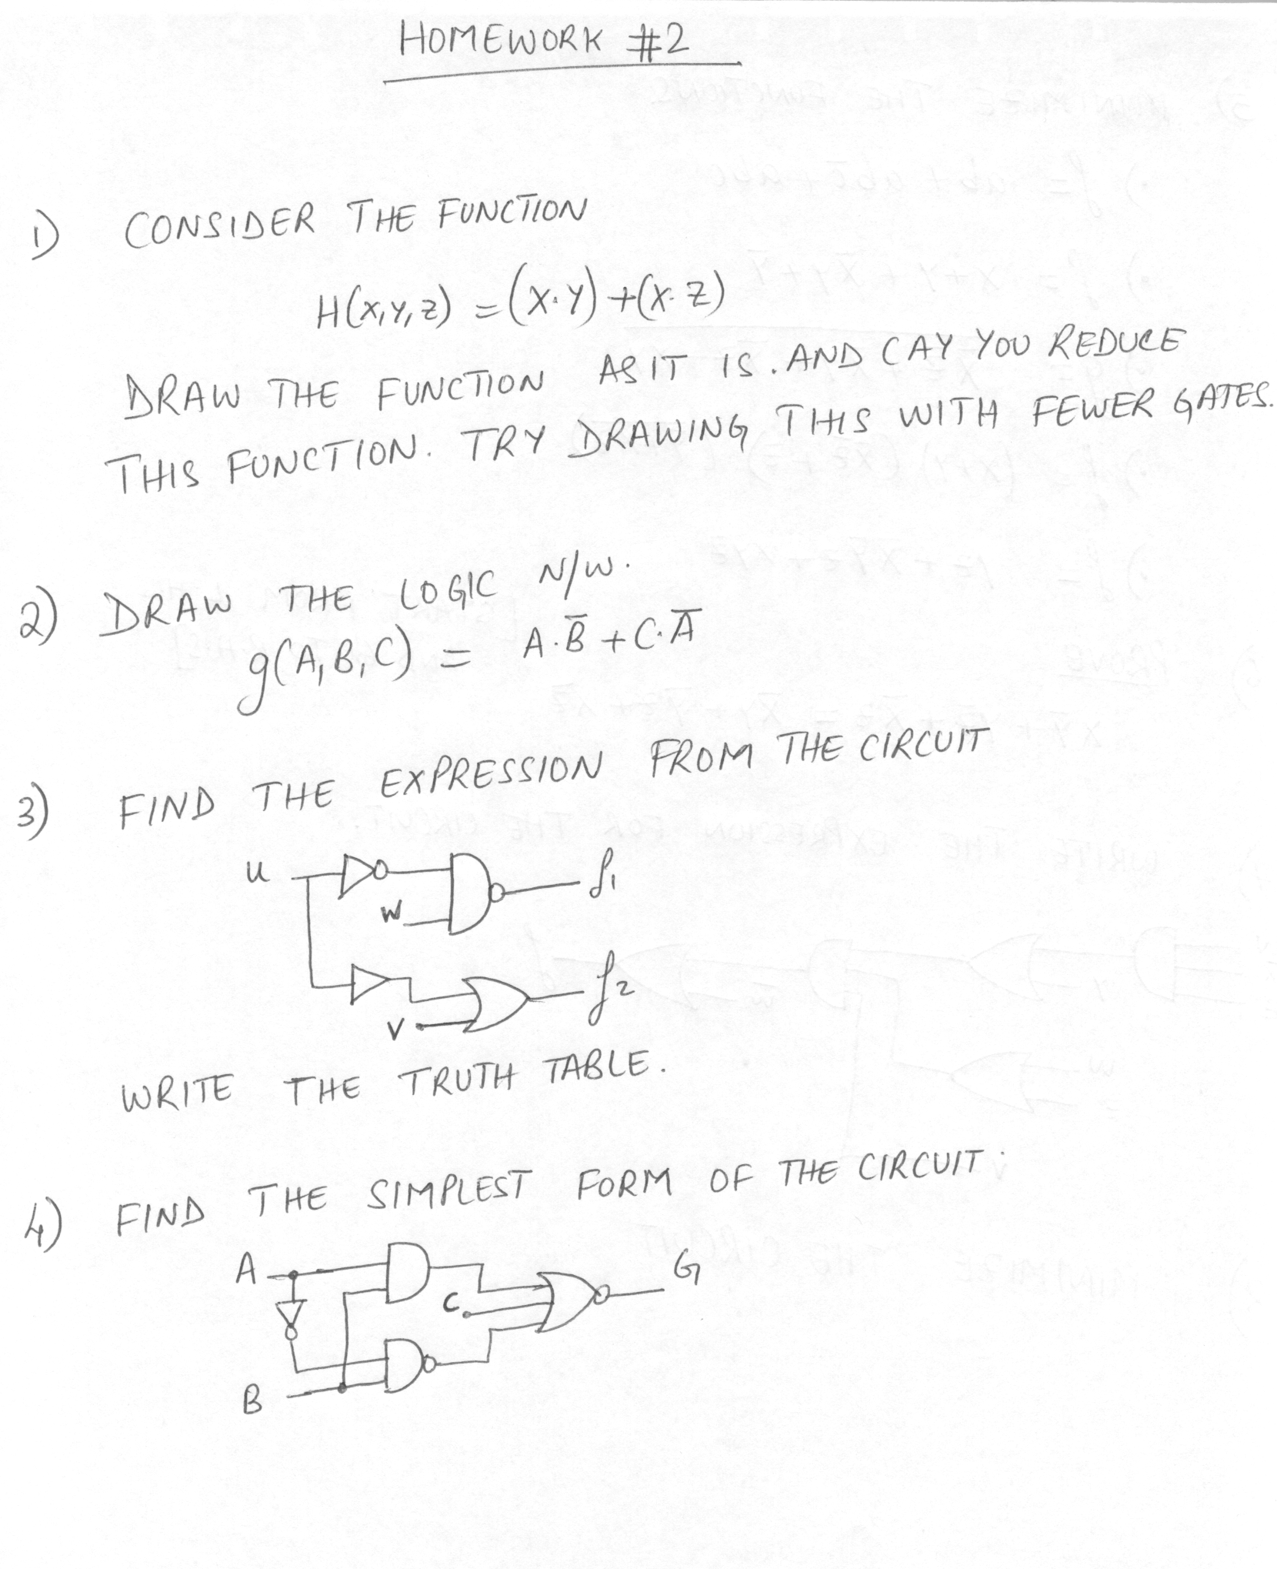

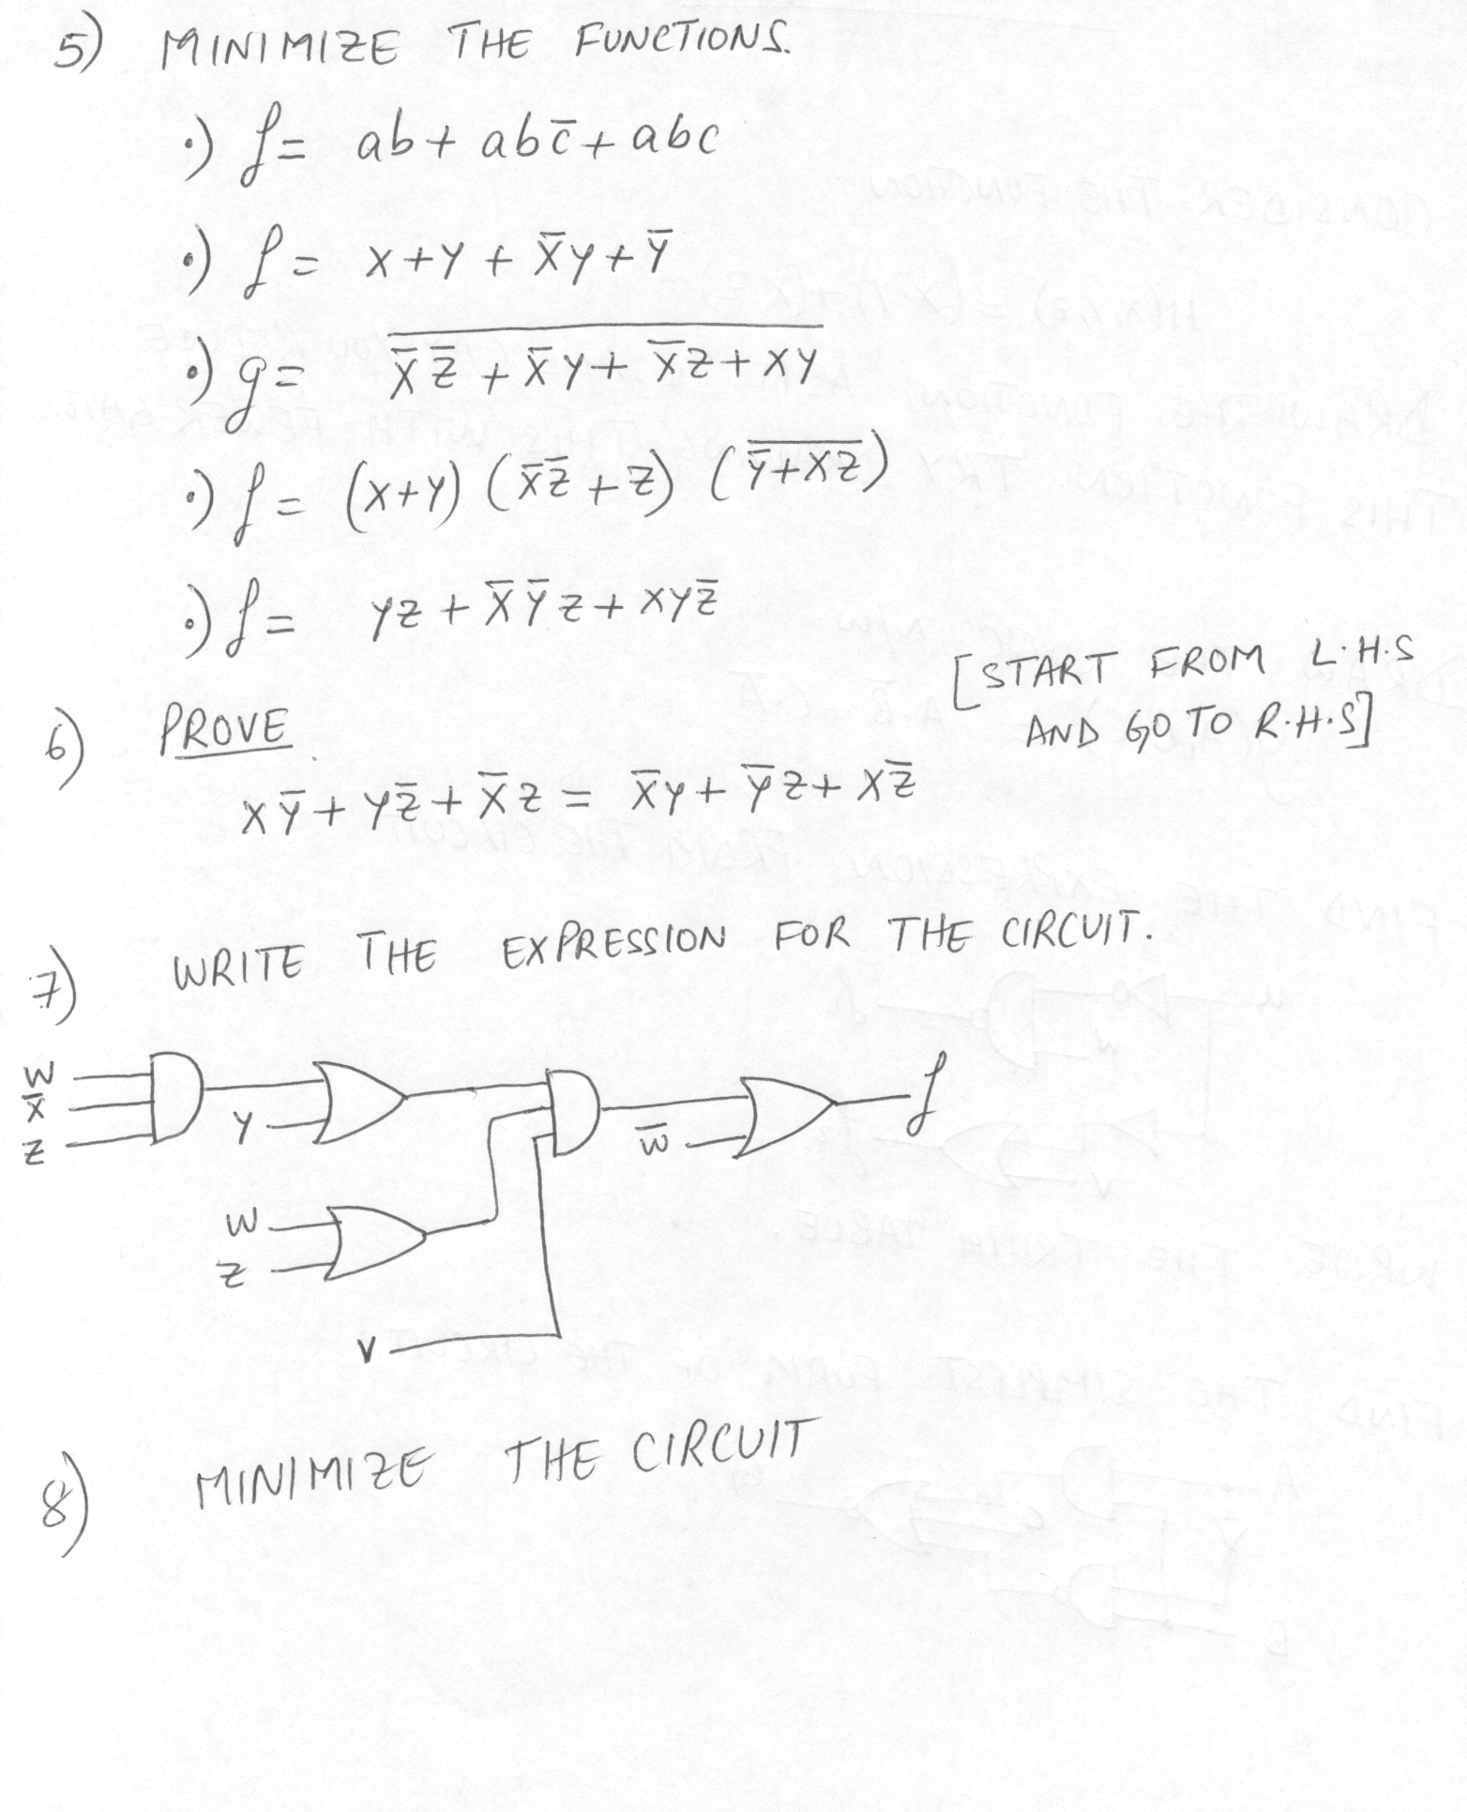

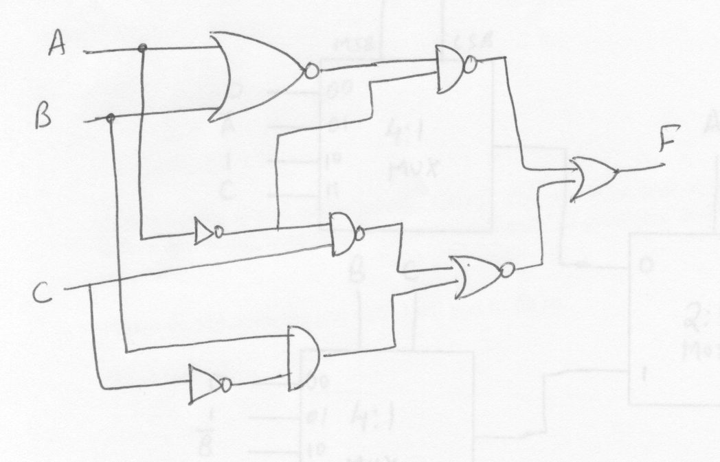

Additional questions:
1) Show that basic gates (NOT, OR and AND) can be built using just only NAND gates. Thus proving that a NAND gate is a universal gate.

